Section 1: Case Summary

Scenario Title: | WPW Wide Complex Tachycardia
Keywords: | Tachycardia, Wide complex, ACLS, WPW, cardioversion, AV nodal blocker
Brief Description of Case: | A 37F with wide complex tachycardia (wolfe-parkinson-white) presents, initially stable, and after unsuccessful treatments, decompensates to unstable atrial fibrillation, and requires synchronized cardioversion.

Goals and Objectives
Educational Goal: | Recognition of wide complex tachycardia
Objectives:  (Medical and CRM) | - Recognize wide complex tachycardia  - Follow the ACLS tachycardia (stable and unstable) algorithm  - Communicate clearly with team during a resuscitation including closed loop communication
EPAs Assessed: | C1: Resuscitating and coordinating care for critically ill patients

Learners, Setting and Personnel
Target Learners: | ☒ Junior Learners |  | ☒ Senior Learners |  |  | ☐ Staff
 | ☐ Physicians | ☐ Nurses |  | ☐ RTs | ☐ Inter-professional
 | ☐ Other Learners:
Location: | ☒ Sim Lab |  | ☐ In Situ |  |  | ☐ Other:
Recommended Number of Facilitators: | Instructors: 1 - 2
 | Sim Actors:
 | Sim Techs: 1

Scenario Development
Date of Development: | May 25, 2022
Scenario Developer(s): | Kelly Huang, PGY-3
Affiliations/Institutions(s): | University of British Columbia, Department of Emergency Medicine
Contact E-mail: | Kelly.huang@alumni.ubc.ca
Last Revision Date:
Revised By:
Version Number:

Section 2A: Initial Patient Information

- Patient Chart
Patient Name: Vanessa |  |  |  | Age: 32 | Gender: F | Weight: 70kg
Presenting complaint: Palpitations
Temp: 37.1 | HR: 185 | BP: 115/75 |  | RR: 22 | O₂Sat: 97% | FiO₂: RA
Cap glucose: 5.1 |  |  |  | GCS: 15
Triage note:
37F with 3 hour history of palpitations. It started when she was driving her kids to school and has gotten worse. She denies any recreational drug use. She denies any cardiac history.

Allergies: NKDA
Past Medical History:  Depression |  |  | Current Medications:  Escitalopram

Section 2B: Extra Patient Information

A. Further History
- No recent long-haul flights or immobilization
- No previous DVT or PE
- No active cancer, hemoptysis, or leg swelling
- Family history is non contributory
B. Physical Exam
Cardio: tachycardia, no murmurs | Neuro: GCS 15, no focal deficits
Resp: mild respiratory distress, clear to bases | Head & Neck: normal
Abdo: soft, non tender | MSK/skin: normal
Other: looks uncomfortable and complains that it feels weird

Section 3: Technical Requirements/Room Vision

A. Patient
☒ Mannequin (specify type and whether infant/child/adult)
☐ Standardized Patient
☐ Task Trainer
☐ Hybrid
B. Special Equipment Required
Crash cart with defibrillator

C. Required Medications
Procainamide, ketamine, fentanyl
Possibly adenosine, amiodarone, sotalol

D. Moulage
None required

E. Monitors at Case Onset
☒ Patient on monitor with vitals displayed
☐ Patient not yet on monitor
F. Patient Reactions and Exam
None

Section 4: Sim Actor and Standardized Patients

None needed
Section 5: Scenario Progression

Scenario States, Modifiers and Triggers
Patient State/Vitals | Patient Status | Learner Actions, Modifiers & Triggers to Move to Next State |  | Facilitator Notes
1. Baseline State  Rhythm: regular wide complex tachycardia  HR: 180  BP: 125/85  RR: 22 O₂SAT: 97 %  T: 37.1ºC GCS: 15 | Alert, uncomfortable, responsive | Expected Learner Actions  Order ECG  Obtain IV access  Apply cardioresp monitors and defib pads  Focused exam  Focused history  Recognize wide complex tachycardia  Attempt chemical cardioversion (procainamide) | Modifiers  - show ECG #1 when ordered  - show CXR & labs when ordered  Triggers  - AV nodal blocker phase 2  - Procainamide/amiodarone phase 3  - Electrical cardioversion patient refuses  - After 4 minutes phase 2 | If team elects to do an electrical cardioversion, patient will refuse “That sounds unpleasant, can we try something else?”
2. Polymorphic VT  Rhythm: irregular polymorphic ventricular tachycardia  HR: 200  BP: 88/60 RR: 22  O2: 97% GCS: 14 | Drowsy, eyes half closed | Expected Learner Actions  Call for help  Repeat set of vitals  Perform synchronized cardioversion  Consider light hemodynamically neutral sedation/analgesia | Modifiers  - if 2 mins pass and rhythm change not noticed, RN to prompt “it seems the rhythm looks different now”  Triggers  - Synchronized cardioversion -> phase 3
3. Hypotension  Rhythm: regular wide complex tachycardia  HR: 180  BP: 88/60 RR: 22  O2: 97% GCS: 14 | Eyes half open, not as responsive | Expected Learner Actions  Call for help if not already done  Discontinue antiarrhythmic infusion  Recognize persistent hypotension (repeat vitals)  Synchronized cardioversion | Triggers  - Synchronized cardioversion -> phase 4 | Hypotension persists from previous antiarrhythmic, prompting repeat electrically cardiovert
4. Stable  Rhythm: sinus with delta waves  HR: 82  BP: 122/90 RR: 16  O2: 97% GCS: 15 | Responsive | Expected Learner Actions  Order repeat ECG and repeat vital signs  Consult cardiology for further guidance of management and workup | Modifiers  - Show ECG #3 once ordered  Triggers  - Cardiology pages back and end case | - Show ECG #3

Appendix A: Laboratory Results

CBC  WBC 6.0  Hgb 132  Plt 310  Lytes  Na 141  K 4.0  Cl 108  HCO₃  Cr 80  Glucose 6.1 | Cardiac/Coags  hsTrop 8  D-dimer 210  INR 1.1  aPTT 37  Other  B-HCG neg

Appendix B: ECGs, X-rays, Ultrasounds and Pictures
ECG #1
Wide complex regular tachycardia (antidromic AVRT)

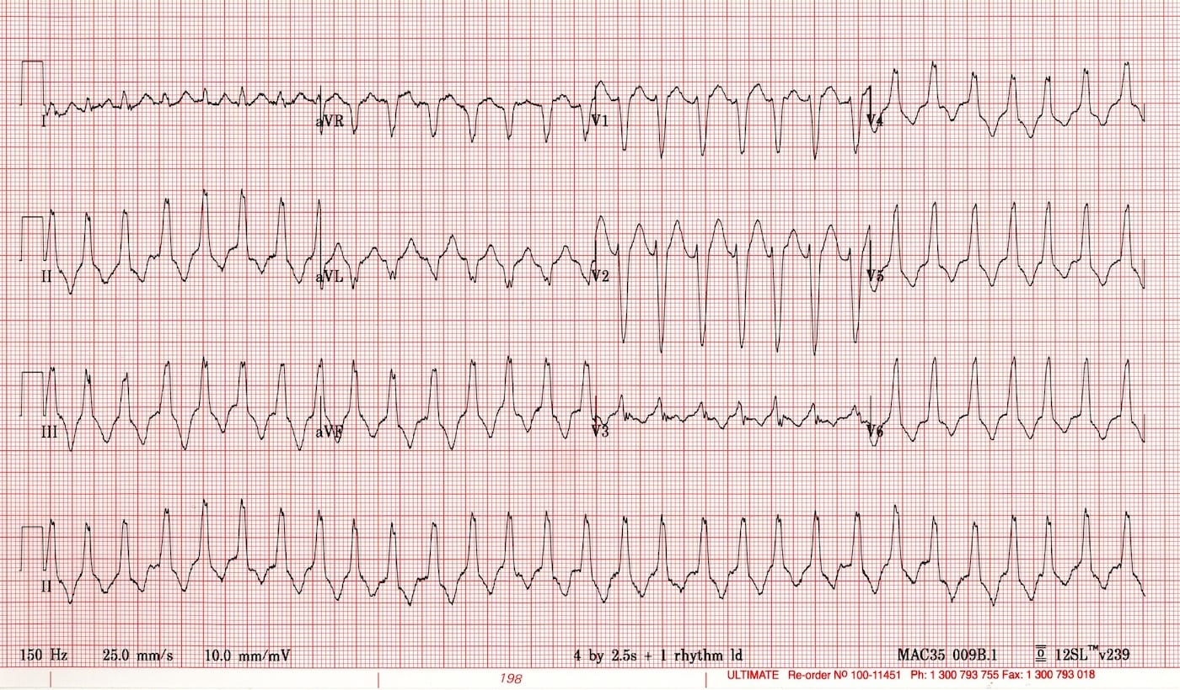

Source: https://litfl.com/wp-content/uploads/2019/04/WCTfeb2012-1.jpg

ECG#2: Irregular, polymorphic wide complex tachycardia (afib with WPW)
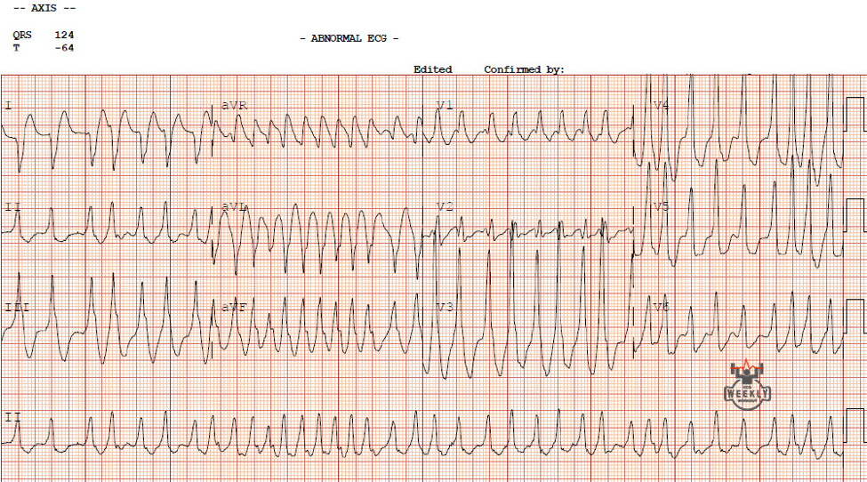

Source: https://www.acc.org/education-and-meetings/patient-case-quizzes/2020/03/09/09/00/treatment-of-wide-complex-tachycardias#

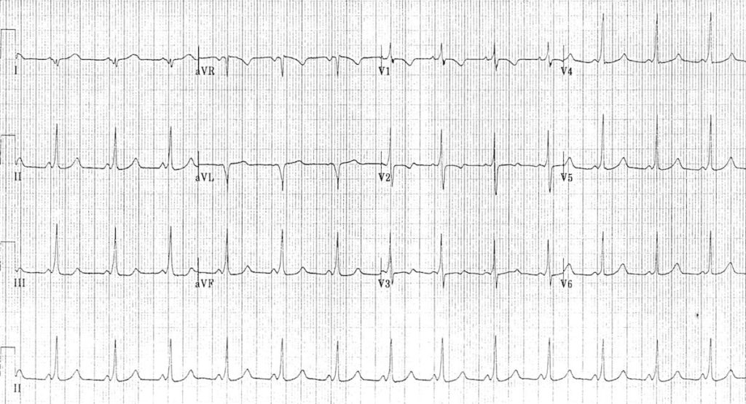
ECG #3: sinus rhythm with WPW
Source: https://litfl.com/wp-content/uploads/2018/08/Orthodromic-AVRT-post-adenosine-1-2.jpg

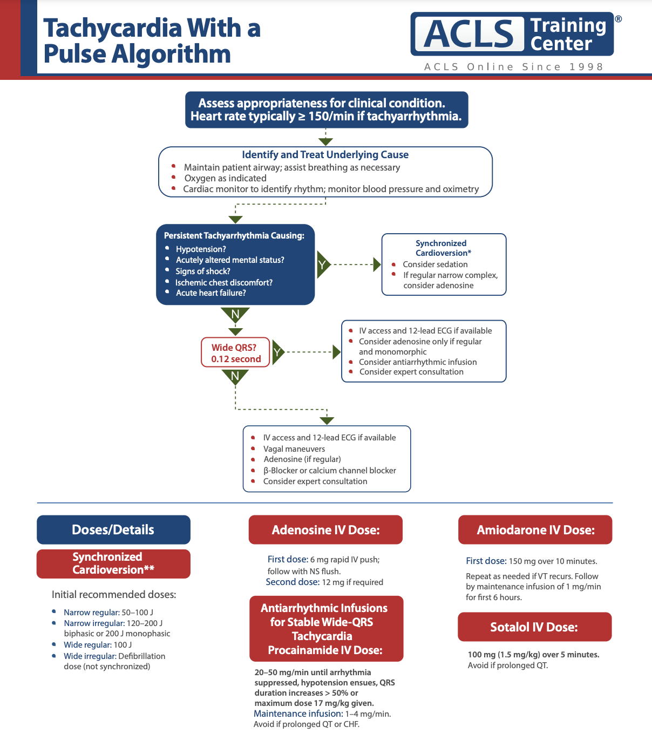
Appendix C: Facilitator Cheat Sheet & Debriefing Tips

Objectives:
- Recognition of wide complex tachycardia
- Following the stable tachycardia ACLS algorithm
- Recognition of unstable tachycardia with a pulse
- Differential diagnosis of wide complex tachycardia
- Communicating clearly with team in during an unstable cardiac resuscitation
- Closed loop communication

Key moments to reflect on:
- Identification of WCT
- Discussion or recognition of the differential of WCT, including pre-excitation
- Recognition of when patient turned unstable
- Performing electrical cardioversion

Sample debriefing questions:
- What was everyone’s understanding of the rhythm that the patient was in and its management?
- What memory aids could you use to reduce cognitive load?

References

1. ACLS algorithm 2020
2. Life in the fast lane
3. ACC.org

